**PROJECT REPORT**

On

“BHARAT TOURIST**”**

**Submitted to**

Rashtrasant Tukadoji Maharaj Nagpur University, Nagpur

In Partial Fulfilment of the requirement of

**Bachelor of Commerce (Computer Application)**

**Submitted by**

FLANSH GAJBHIYE

ISHA RAUT

HIMANSHU GAJBHIYE

**Under the Guidance of**

Prof. Saudamini Jivtode



**Dr. Ambedkar Institute of Management Studies & Research DeekshaBhoomi, Nagpur-440010**

**(2022-2023)**

**CERTIFICATE**

This is to certify that **Flansh Gajbhiye , Isha Raut , Himanshu Gajbhiye** have satisfactorily completed the project work entitled **“Bharat Tourist”** is not less than one academic session. This also certify that this project work is the result of the candidate’s own work and is of sufficiently high standard to warrant its presentation for the B.Com (Computer Application ) program.

To the best of my knowledge this project or its part has not been submitted to this university or any other university for any Degree/Diploma.

Prof. Saudamini Jivtode

**Guide Name**

**Internal Examiner**

**External Examiner**

**Place:    Nagpur**

**Date:**      **Director**

**DECLARATION**

We, **Flansh Gajbhiye , Isha Raut , Himanshu Gajbhiye** hereby declare that the project entitled **“Bharat Tourist”** is the outcome of our own research work based on personal study during academic session 2022– 2023 and has not been submitted previously for award of any degree or diploma to this university or any other university.

FLANSH GAJBHIYE

ISHA RAUT

HIMANSHU GAJBHIYE

**ACKNOWLEDGEMENT**

“Words have never expressed human sentiments. This is only an attempt to express our deep gratitude which comes from our heart.”

It is a great pleasure for us to express our deep feeling of gratitude to our respected guide **Prof. Jayant Gondane (Assistant Professor ,** **Dr. Ambedkar Institute of Management Studies & Research, Nagpur)** for his/her great encouragement and  unfailing support which provided needed moral and  confidence to carry on our work.

We are grateful to the **Dr. S. S. Fulzele**, (**Director, Dr. Ambedkar Institute of Management Studies & Research, Nagpur)** for making all facilities available for our work.

It is with profound gratitude that we wish to express our indebtedness to **Dr.  Nirzar  Kulkarni** (**Associate Director, Dr. Ambedkar Institute of Management Studies & Research, Nagpur**) for his invaluable guidance and supervision in completion of this project work.

We are greatful to our parents for their lovable support. Last but not least we are thankful to our friends and other faculty members for their direct and indirect help for completion of this work.

**Contents.**

1. Introduction.
2. Objectives.
3. Preliminary System Analysis.

* Preliminary Investigation
* Present System in Use.
* Flaws in Present System.
* Need of New System.
* Feasibility Study.
* Project Category.

1. Software  Engineering  Paradigm  Applied
   * Modules
   * System / Modular Chart.

1. Software & Hardware Requirement Specification.
2. Detailed System Analysis.
   * Data Flow Diagram.
   * Numbers of Modules and Process Logic.
   * Data Structures and Tables.
   * Entity-Relationship Diagram.

1. System Design.
   * Form Design.
   * Source Code.
   * Input screen & Output Screen.
2. Testing &Validation Checks.
3. System Security Measures.
4. Implementation, Evaluation and Maintenance.
5. Future Scope of the project.
6. Suggestion & Conclusion
7. Bibliography& References

INTRODUCTION

Welcome to the vibrant and culturally diverse country of India! Our tourist website is dedicated to providing you with an unforgettable experience as you explore the sights, sounds, and flavors of this incredible nation.

India is a land of breathtaking beauty, from the snow-capped peaks of the Himalayas to the sun-kissed beaches of Goa, and everything in between. With a rich history that spans thousands of years, India is home to some of the world's most awe-inspiring monuments, including the iconic Taj Mahal, the magnificent forts and palaces of Rajasthan.

But India is much more than just its landmarks. It's a country of contrasts and contradictions, where modern technology coexists with ancient traditions, and bustling cities sit alongside tranquil rural villages. It's a place where you'll find colorful markets, mouth-watering cuisine, and warm hospitality that will make you feel right at home.

Whether you're a history buff, a foodie, an adventure seeker, or simply looking for a relaxing getaway, India has something to offer everyone. So come, explore this land of wonders, and discover the magic of India for yourself.

India's history dates back to over 5,000 years, and this is evident in the country's stunning architectural wonders, including the iconic Taj Mahal, ancient temples, and forts. India is also home to a diverse range of flora and fauna, with over 100 national parks and wildlife sanctuaries that house exotic species such as tigers, elephants, and rhinos.

The country's culinary scene is equally diverse and delicious, with a range of mouth-watering delicacies that will satisfy any taste bud. India is also famous for its textiles, handicrafts, and festivals, which provide an insight into the country's vibrant cultural heritage.

At our Indian tourist website, we aim to provide you with all the information you need to plan your perfect Indian vacation. Our website features comprehensive travel guides, accommodation options, and tour packages to suit your needs and budget. Whether you're looking for adventure, relaxation, or a cultural immersion, India has something for everyone. So come and explore the incredible diversity and beauty of India. Let us help you plan an unforgettable journey that will leave you with memories to last a lifetime.

OBJECTIVE

The objective of a tourist website can vary depending on the specific goals of the website and the target audience. Here are some possible objectives for a tourist website:

1. Inform and educate: The website can provide information about a destination, its history, culture, attractions, and things to do. This can help tourists plan their trip and make informed decisions about what to see and do.

2. Promote tourism: The website can promote tourism in a particular destination by highlighting its unique features, attractions, and experiences. This can encourage visitors to choose that destination over others.

3. Generate bookings: The website can provide a booking engine or link to booking platforms to help visitors book flights, accommodations, and activities. This can generate revenue for the website and its partners.

4. Provide customer service: The website can provide customer service by answering common questions, providing contact information, and offering assistance with trip planning and booking.

5. Build a community: The website can create a community of travelers by providing forums, social media integration, and user-generated content. This can encourage repeat visits and build brand loyalty.

6. Measure success: The website can track user behavior, engagement, and conversion rates to measure the success of its objectives and optimize its performance.

POTENTIAL NEEDS

Here are some potential needs to consider when designing a tourist website for Indian visitors:

1. Cultural Information: Indian visitors may be interested in cultural information and historical context about the destinations they are visiting. Providing information about festivals, traditional arts and crafts, and local cuisine can also be helpful.

2. Language Support: As India has a wide range of languages, providing multilingual support on the website can improve the user experience for Indian visitors who may not be fluent in English.

3. Accessibility: Many Indian tourists may be budget-conscious and may be looking for affordable travel options. Providing information on budget-friendly accommodations, transportation options, and local activities can help attract these visitors.

4. Visa and Travel Documentation: Providing information about visa requirements, travel documents, and any necessary health information for foreign travel can be helpful for Indian visitors.

5. Regional Tourism: India is a large country with diverse regions and attractions. Providing information about different regions and their unique tourist destinations can be helpful for visitors who are interested in exploring various parts of the country.

6. Trusted Reviews: Indian visitors often rely on word-of-mouth recommendations from friends and family when planning their travel. Providing genuine reviews and ratings of accommodations, restaurants, and activities on the website can help build trust and encourage visitors to book through the website.

PRELIMINARY INVESTIGATION

Here are some steps that can be taken for a preliminary investigation for an Indian tourist website:

1. Conduct Market Research: Conduct research to identify the target audience for the website, their demographics, preferences, and travel behavior. Identify key competitors and analyze their website design, content, and user experience.

2. Identify Key Destinations: Identify popular tourist destinations in India and understand the unique features and attractions of each destination. This can help to tailor the website content and user experience to the needs of visitors.

3. Define Website Objectives: Determine the objectives of the website, such as promoting tourism, generating bookings, providing information, or building a community of travelers. This will help to guide the design and content of the website.

4. Create Content: Develop high-quality, informative, and engaging content for the website that highlights the attractions, history, culture, and experiences of each destination. Consider providing multilingual support to cater to visitors from different regions of India.

5. Design the User Experience: Develop a user-friendly website design that is easy to navigate and provides a seamless booking experience for visitors. Use responsive design to ensure that the website is accessible on all devices, including mobile phones and tablets.

6. Develop a Marketing Plan: Develop a marketing plan to promote the website and attract visitors. This can include search engine optimization, social media marketing, paid advertising, and partnerships with travel agencies and tourism boards.

7. Test and Refine: Test the website with users to identify any usability issues or areas for improvement. Continuously monitor website metrics and user feedback to refine the website and improve its performance over time.

PRESENT SYSTEM IN USE

There are several needs that an Indian tourist website can fulfill:

1. Information and Education: A tourist website can provide comprehensive information and education about tourist destinations, attractions, and activities in India. This can help visitors plan their trip and make informed decisions about where to go and what to see.

2. Convenience: A tourist website can provide visitors with a convenient way to plan and book their trip. Visitors can search and book accommodations, transportation, and activities all in one place.

3. Affordability: Many Indian tourists are budget-conscious and are looking for affordable travel options. A tourist website can provide information on budget-friendly accommodations, transportation options, and local activities, making it easier for visitors to plan an affordable trip.

4. Safety and Security: Travel safety is a major concern for tourists. A tourist website can provide information on travel safety and security, including health and medical information, local laws, and emergency contacts.

5. Cultural Experience: India is a country with a rich history and diverse cultural heritage. A tourist website can provide visitors with information about cultural events, festivals, and traditions, allowing them to have a more immersive cultural experience.

6. Sustainability: Sustainability and responsible travel are becoming increasingly important to tourists. A tourist website can provide information on sustainable tourism practices, eco-friendly accommodations, and activities that promote sustainable tourism.

FEASIBILITY STUDY

A feasibility study for an Indian tourist website would typically include the following elements:

1. Market Analysis: Conduct a thorough market analysis to determine the demand for a tourist website in India. Analyze the existing competition, target audience, and market trends to identify opportunities and challenges.

2. Technical Feasibility: Determine the technical feasibility of developing a tourist website by evaluating the available resources, including the required infrastructure, technology, and personnel.

3. Financial Feasibility: Evaluate the financial feasibility of the tourist website by analyzing the costs associated with website development, maintenance, marketing, and operations. Determine the revenue streams, such as booking fees or advertising revenue, and estimate the potential profits.

4. Legal and Regulatory Feasibility: Evaluate the legal and regulatory feasibility of developing a tourist website by analyzing the existing regulations, licensing requirements, and legal issues that may impact website development and operations.

5. Operational Feasibility: Determine the operational feasibility of developing and managing the website by analyzing the required processes, resources, and personnel. Evaluate the risks associated with website development, including cybersecurity threats, and develop mitigation strategies.

6. Marketing Feasibility: Determine the marketing feasibility of the tourist website by analyzing the target audience, the existing competition, and the potential marketing channels. Develop a marketing plan that includes strategies to attract visitors to the website and build brand recognition.

7. Organizational Feasibility: Determine the organizational feasibility of developing and managing the tourist website by analyzing the required resources, personnel, and organizational structure. Determine the roles and responsibilities of the team members, and develop a plan for managing the website's operations and growth.

PROJECT CATEGORY

The project category of an Indian tourist website could fall under the following categories:

1. Travel and Tourism: This category includes websites that provide information on tourist destinations, travel packages, accommodation options, transportation facilities, and other related services.

2. Culture and Heritage: This category includes websites that focus on promoting India's rich cultural and historical heritage, such as its ancient monuments, temples, forts, and palaces.

3. Adventure Tourism: This category includes websites that cater to adventure tourists, providing information on activities such as trekking, camping, wildlife safaris, water sports, and other adventure sports.

4. Medical Tourism: This category includes websites that provide information on medical facilities and services available in India, particularly for foreigners seeking medical treatment and procedures at affordable prices.

5. Pilgrimage Tourism: This category includes websites that promote India's religious and spiritual tourism, providing information on important pilgrimage sites and associated rituals and customs.

6. Eco-Tourism: This category includes websites that focus on promoting sustainable and responsible tourism practices, highlighting India's natural beauty and biodiversity, and encouraging visitors to explore and enjoy these resources while preserving them for future generations.

SOFTWARE ENGINEERING PARADIGN APPLIED

MODULES

BOOK

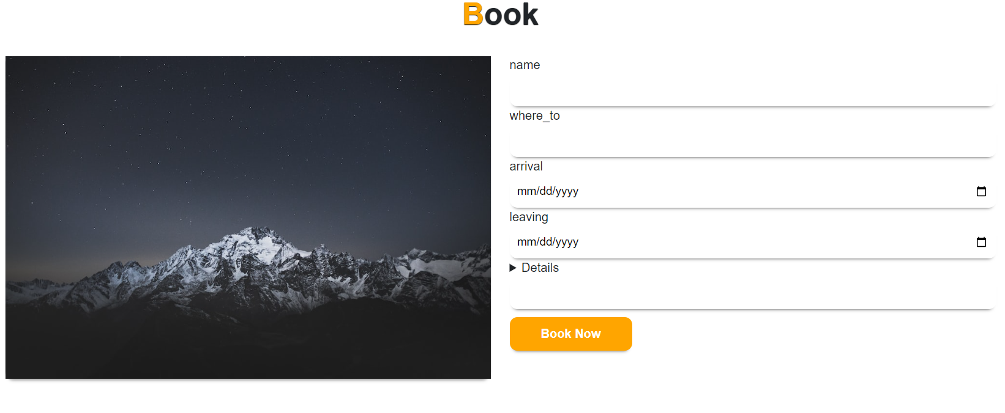

<form action="booking.php" method="post">

            <div class="form-group">

              <label> name</label>

              <input type="text" name="name" autocomplete="off" class="form-control">

            </div>

            <div class="form-group">

              <label> where_to</label>

              <input type="text" name="where_to" autocomplete="off" class="form-control">

            </div>

            <div class="form-group">

              <label> arrival</label>

              <input type="date" name="arrival" autocomplete="off" class="form-control">

            </div>

            <div class="form-group">

              <label> leaving</label>

              <input type="date" name="leaving" autocomplete="off" class="form-control">

            </div>

            <div class="form-group">

              <label>

                <details></details>

              </label>

              <input type="text" name="details" autocomplete="off" class="form-control">

            </div>

            <input type="submit" value="Book Now" class="submit" required>

          </form>

SYSTEM / MODULAR CHART

DETAILS

ARRIVAL

leaving

WHERE_TO

NAME

SOFTWARE AND HARDWARE

REQUIREMENT SPECIFICATION

Software Requirements:

1. Operating System: The website should be compatible with various operating systems like Windows, Mac, and Linux.

2. Web Server: Apache, Nginx, or IIS can be used as the web server.

3. Programming Language: The website can be developed using programming languages such as HTML, CSS, JavaScript, and PHP.

4. Content Management System: The website can be built on CMS platforms like WordPress or Drupal to manage the content.

5. Database: MySQL or PostgreSQL can be used as the database management system.

Hardware Requirements:

1. Processor: The website should be compatible with different processor architectures such as Intel, AMD, and ARM.

2. RAM: The website should run smoothly with a minimum of 2GB RAM.

3. Storage: The website should have sufficient storage space for hosting content and media files.

4. Internet Connection: A fast and reliable internet connection is required to ensure that the website loads quickly.

5. Server: The website should be hosted on a dedicated server or a cloud-based server to ensure its availability and scalability.

Additional Requirements:

1. The website should be responsive, which means it should be compatible with different screen sizes and devices like smartphones, tablets, and desktops.

2. The website should be optimized for search engines to improve its visibility and attract more visitors.

3. The website should have a user-friendly interface and easy navigation to improve the user experience.

4. The website should be secure with an SSL certificate to protect user data and transactions.

5. The website should have features like booking and payment options, feedback and review system, and social media integration to enhance its functionality and engagement.

DETAILED SYSTEM ANALYSIS

Data Structures and Analysis

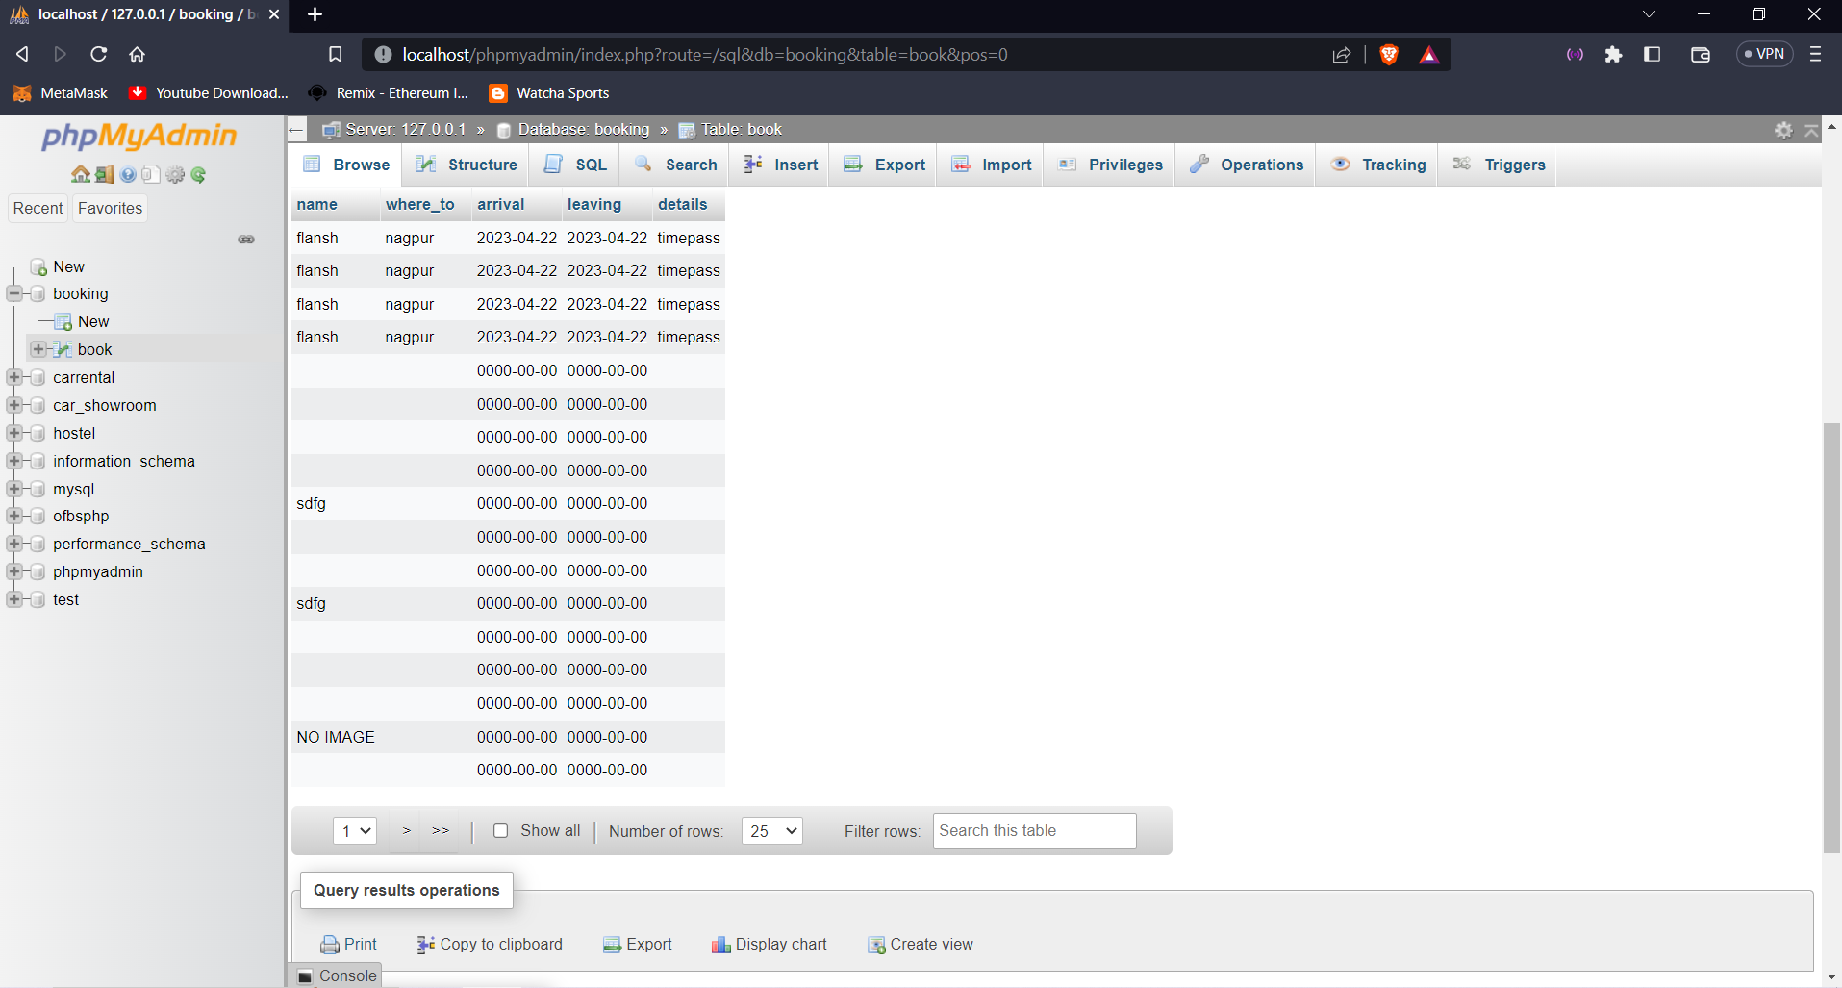

SYSTEM DESINGN

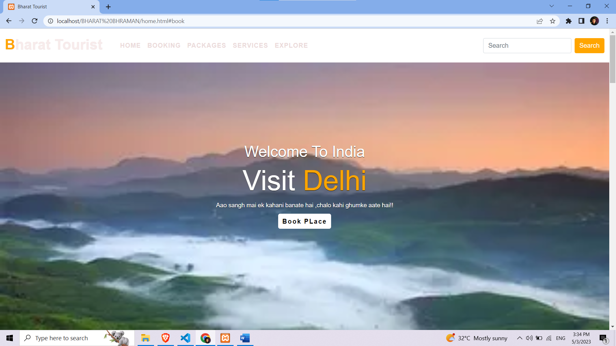

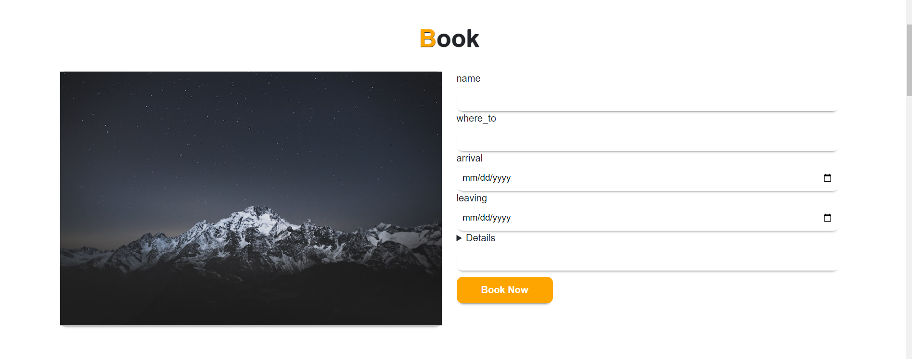

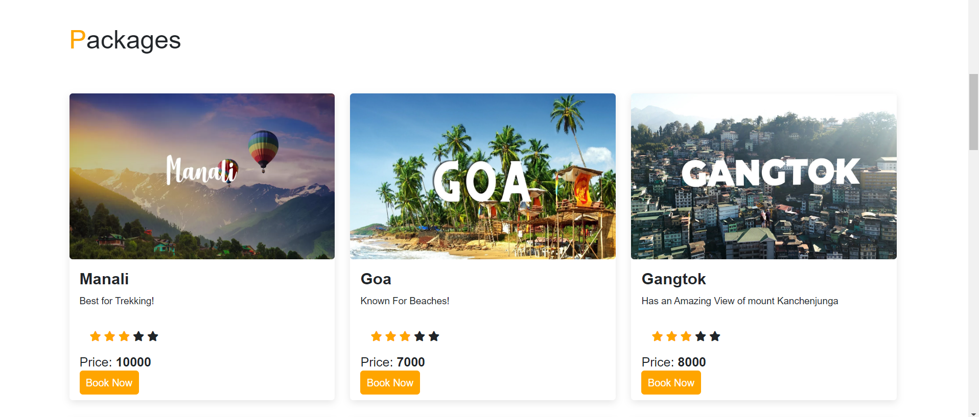

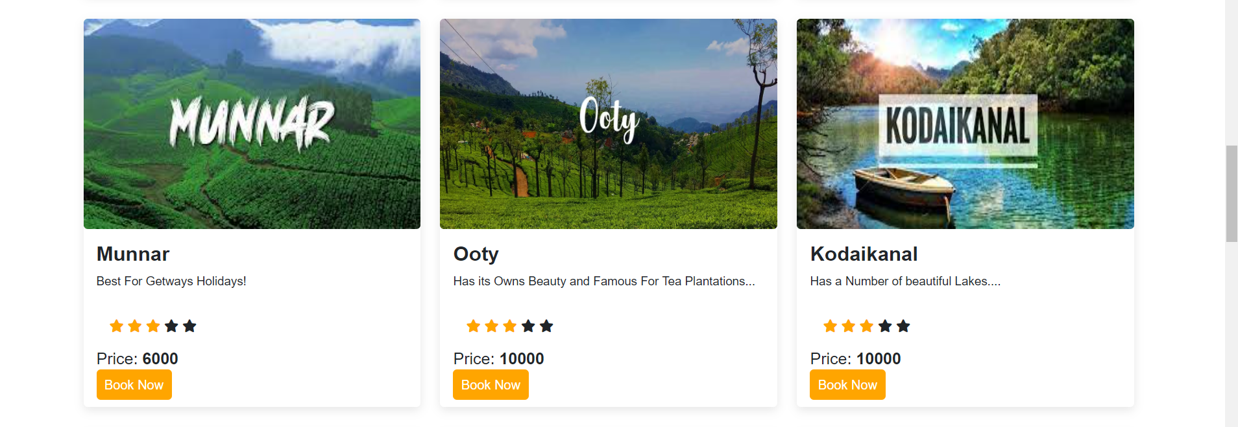

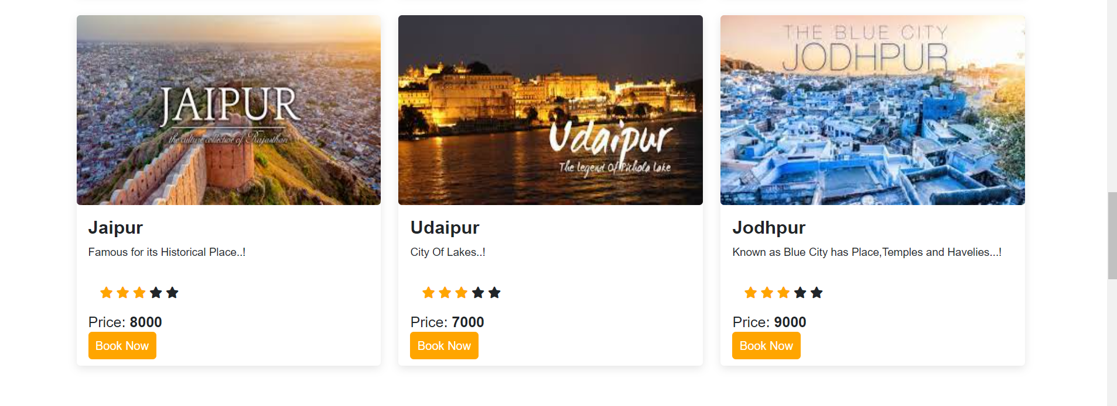

SERVICES

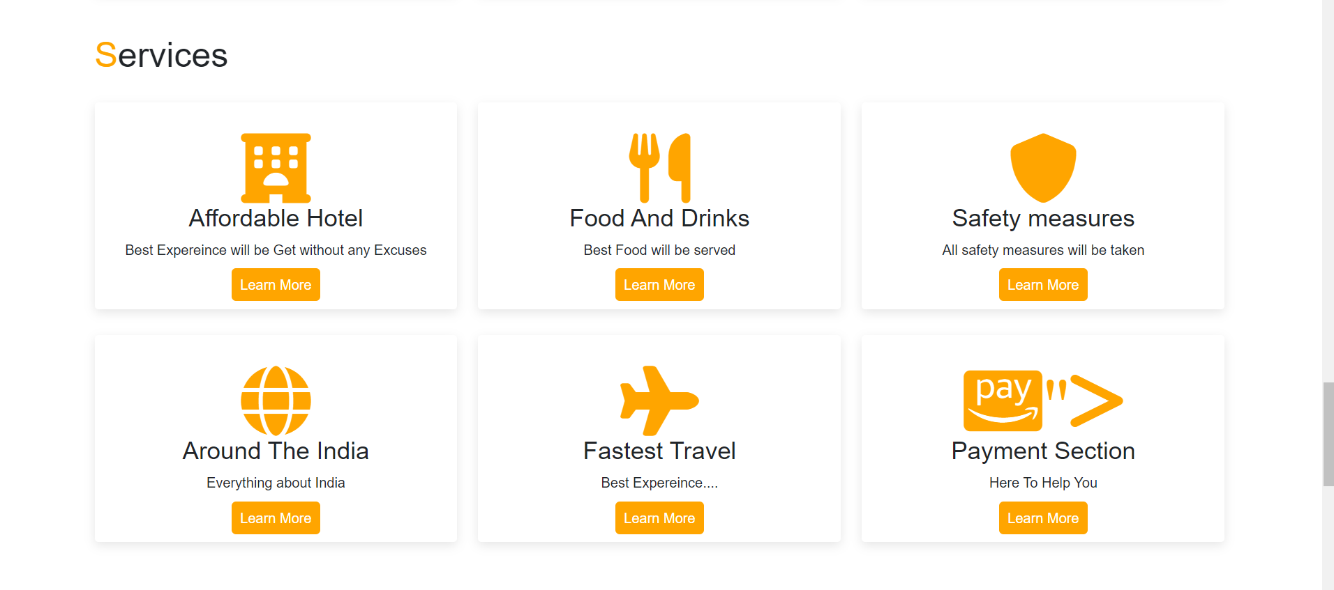

EXPLORE

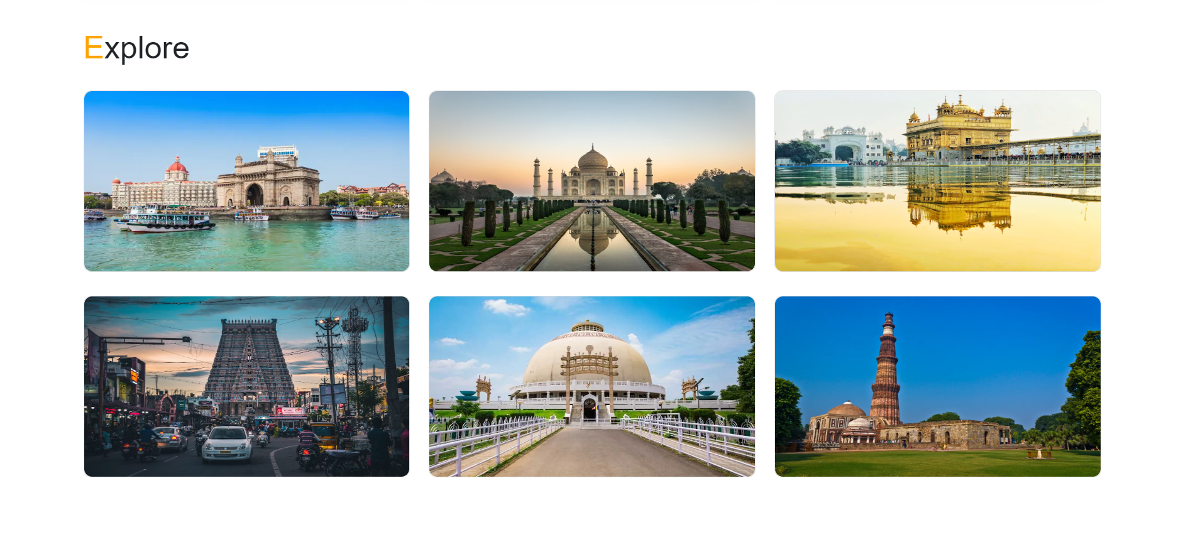

ABOUT US

Established in 2022, Bharat Tourist has since positioned itself as one of the leading companies, providing great offers, competitive airfares, exclusive discounts, and a seamless online booking experience to many of its customers. The experience of booking your flight tickets, hotel stay, and holiday package through our desktop site or mobile app can be done with complete ease and no hassles at all. We also deliver amazing offers, such as Instant Discounts, Fare Calender and many more while updating them from time to time to better suit our customers’ evolving needs and demands.

mail us :- BharatTourist@gmail.com | telephone :- 789654123 | address :- Nagpur, Maharashtra, India.

BCCA 3year PROJECT  
Flansh Gajbhiye | Isha Raut | Himanshu Gajbhiye

SOURCE CODE

HOME.HTML

<html lang="en">

<head>

  <meta charset="UTF-8">

  <meta http-equiv="X-UA-Compatible" content="IE=edge">

  <meta name="viewport" content="width=device-width, initial-scale=1.0">

  <title>Bharat Tourist</title>

</head>

<body>

  <!-- Navbar Start-->

  <nav class="navbar navbar-expand-lg " id="navbar">

    <div class="container-fluid">

      <a class="navbar-brand" href="home.html" id="logo"><span>B</span>harat Tourist</a>

      <button class="navbar-toggler" type="button" data-bs-toggle="collapse" data-bs-target="#mynavbar">

        <span><i class="fa-solid fa-bars"></i></span>

      </button>

      <div class="collapse navbar-collapse" id="mynavbar">

        <ul class="navbar-nav me-auto">

          <li class="nav-item">

            <a class="nav-link" href="home.html">HOME</a>

          </li>

          <li class="nav-item">

            <a class="nav-link" href="#book">BOOKING</a>

          </li>

          <li class="nav-item">

            <a class="nav-link" href="#packages">PACKAGES</a>

          </li>

          <li class="nav-item">

            <a class="nav-link" href="#services">SERVICES</a>

          </li>

          <li class="nav-item">

            <a class="nav-link" href="#Explore">EXPLORE</a>

          </li>

        </ul>

        <form class="d-flex">

          <input class="form-control me-2" type="text" placeholder="Search">

          <button class="btn btn-primary" type="button">Search</button>

        </form>

      </div>

    </div>

  </nav>

  <!-- Navbar End-->

  <!--Home Section Start-->

  <div class="home" >

    <div class="content">

      <h5>Welcome To India</h5>

      <h1>Visit <span class="changecontent"></span></h1>

      <P>Aao sangh mai ek kahani banate hai ,chalo kahi ghumke aate hai!!</P>

      <a href="http://localhost/BHARAT%20BHRAMAN/#book">Book PLace </a>

  <!--Booking Section Start-->

  <section class="book" id="book">

    <div class="container">

      <div class="main-text">

        <h1><span>B</span>ook</h1>

      </div>

      <div class="row">

        <div class="col-md-6 py-3 py-md-0">

          <div class="card">

            <img src="1.jpg" alt="">

          </div>

        </div>

        <div class="col-md-6 py-3 py-md-0">

          <form action="booking.php" method="post">

            <div class="form-group">

              <label> name</label>

              <input type="text" name="name" autocomplete="off" class="form-control">

            </div>

            <div class="form-group">

              <label> where_to</label>

              <input type="text" name="where_to" autocomplete="off" class="form-control">

            </div>

            <div class="form-group">

              <label> arrival</label>

              <input type="date" name="arrival" autocomplete="off" class="form-control">

            </div>

            <div class="form-group">

              <label> leaving</label>

              <input type="date" name="leaving" autocomplete="off" class="form-control">

            </div>

            <div class="form-group">

              <label>

                <details></details>

              </label>

              <input type="text" name="details" autocomplete="off" class="form-control">

            </div>

            <input type="submit" value="Book Now" class="submit" required>

          </form>

        </div>

      </div>

    </div>

  </section>

  <section class="packages" id="packages">

    <div class="container">

      <div class="main-txt">

        <h1><span>P</span>ackages</h1>

      </div>

      <div class="row" style="margin-top: 30px;">

        <div class="col-md-4 py-3 py-md-0">

          <div class="card" style="margin-top: 30px;">

            <img src="manali.jpg" style="height: 260px; width: 100%;" alt="">

            <div class="card-body">

              <h3>Manali</h3>

              <p>Best for Trekking!</p>

              <div class="card-body">

                <i class="fa-solid fa-star checked"></i>

                <i class="fa-solid fa-star checked"></i>

                <i class="fa-solid fa-star checked"></i>

                <i class="fa-solid fa-star "></i>

                <i class="fa-solid fa-star "></i>

              </div>

              <h6>Price: <strong>10000</strong></h6>

              <a href="#book">Book Now</a>

            </div>

          </div>

        </div>

        <div class="col-md-4 py-3 py-md-0">

          <div class="card" style="margin-top: 30px;">

            <img src="goa.jpg" alt="" style="height: 260px; width: 100%;">

            <div class="card-body">

              <h3>Goa</h3>

              <p>Known For Beaches!</p>

              <div class="card-body">

                <i class="fa-solid fa-star checked"></i>

                <i class="fa-solid fa-star checked"></i>

                <i class="fa-solid fa-star checked"></i>

                <i class="fa-solid fa-star "></i>

                <i class="fa-solid fa-star "></i>

              </div>

              <h6>Price: <strong>7000</strong></h6>

              <a href="#book">Book Now</a>

            </div>

          </div>

        </div>

        <div class="col-md-4 py-3 py-md-0">

          <div class="card" style="margin-top: 30px;">

            <img src="gangtok.jpg" alt="" style="height: 260px; width: 100%;">

            <div class="card-body">

              <h3>Gangtok</h3>

              <p>Has an Amazing View of mount Kanchenjunga</p>

              <div class="card-body">

                <i class="fa-solid fa-star checked"></i>

                <i class="fa-solid fa-star checked"></i>

                <i class="fa-solid fa-star checked"></i>

                <i class="fa-solid fa-star "></i>

                <i class="fa-solid fa-star "></i>

              </div>

              <h6>Price: <strong>8000</strong></h6>

              <a href="#book">Book Now</a>

            </div>

          </div>

        </div>

        <div class="col-md-4 py-3 py-md-0">

          <div class="card" style="margin-top: 30px;">

            <img src="munnar.jpg" alt="" style="height: 260px; width: 100%;">

            <div class="card-body">

              <h3>Munnar</h3>

              <p>Best For Getways Holidays!</p>

              <div class="card-body">

                <i class="fa-solid fa-star checked"></i>

                <i class="fa-solid fa-star checked"></i>

                <i class="fa-solid fa-star checked"></i>

                <i class="fa-solid fa-star "></i>

                <i class="fa-solid fa-star "></i>

              </div>

              <h6>Price: <strong>6000</strong></h6>

              <a href="#book">Book Now</a>

            </div>

          </div>

        </div>

        <div class="col-md-4 py-3 py-md-0">

          <div class="card" style="margin-top: 30px;">

            <img src="ooty_2.jpg"alt="" style=" height: 260px; width: 100%;">

            <div class="card-body">

              <h3>Ooty</h3>

              <p>Has its Owns Beauty and Famous For Tea Plantations...</p>

              <div class="card-body">

                <i class="fa-solid fa-star checked"></i>

                <i class="fa-solid fa-star checked"></i>

                <i class="fa-solid fa-star checked"></i>

                <i class="fa-solid fa-star "></i>

                <i class="fa-solid fa-star "></i>

              </div>

              <h6>Price: <strong>10000</strong></h6>

              <a href="#book">Book Now</a>

            </div>

          </div>

        </div>

        <div class="col-md-4 py-3 py-md-0">

          <div class="card" style="margin-top: 30px;">

            <img src="Kodaikanal.jpg" style="height: 260px; width: 100%;" alt="">

            <div class="card-body">

              <h3>Kodaikanal</h3>

              <p>Has a Number of beautiful Lakes....</p>

              <div class="card-body">

                <i class="fa-solid fa-star checked"></i>

                <i class="fa-solid fa-star checked"></i>

                <i class="fa-solid fa-star checked"></i>

                <i class="fa-solid fa-star "></i>

                <i class="fa-solid fa-star "></i>

              </div>

              <h6>Price: <strong>10000</strong></h6>

              <a href="#book">Book Now</a>

            </div>

          </div>

        </div>

        <div class="col-md-4 py-3 py-md-0">

          <div class="card" style="margin-top: 30px;">

            <img src="jaipur.jpg" style="height: 260px; width: 100%;" alt="">

            <div class="card-body">

              <h3>Jaipur</h3>

              <p>Famous for its Historical Place..!</p>

              <div class="card-body">

                <i class="fa-solid fa-star checked"></i>

                <i class="fa-solid fa-star checked"></i>

                <i class="fa-solid fa-star checked"></i>

                <i class="fa-solid fa-star "></i>

                <i class="fa-solid fa-star "></i>

              </div>

              <h6>Price: <strong>8000</strong></h6>

              <a href="#book">Book Now</a>

            </div>

          </div>

        </div>

        <div class="col-md-4 py-3 py-md-0">

          <div class="card" style="margin-top: 30px;">

            <img src="udaipur.jpg" style="height: 260px; width: 100%;" alt="">

            <div class="card-body">

              <h3>Udaipur</h3>

              <p>City Of Lakes..!</p>

              <div class="card-body">

                <i class="fa-solid fa-star checked"></i>

                <i class="fa-solid fa-star checked"></i>

                <i class="fa-solid fa-star checked"></i>

                <i class="fa-solid fa-star "></i>

                <i class="fa-solid fa-star "></i>

              </div>

              <h6>Price: <strong>7000</strong></h6>

              <a href="#book">Book Now</a>

            </div>

          </div>

        </div>

        <div class="col-md-4 py-3 py-md-0">

          <div class="card" style="margin-top: 30px;">

            <img src="jodhpur.jpg" style="height: 260px; width: 100%;" alt="">

            <div class="card-body">

              <h3>Jodhpur</h3>

              <p>Known as Blue City has Place,Temples and Havelies...!</p>

              <div class="card-body">

                <i class="fa-solid fa-star checked"></i>

                <i class="fa-solid fa-star checked"></i>

                <i class="fa-solid fa-star checked"></i>

                <i class="fa-solid fa-star "></i>

                <i class="fa-solid fa-star "></i>

              </div>

              <h6>Price: <strong>9000</strong></h6>

              <a href="#book">Book Now</a>

            </div>

          </div>

        </div>

      </div>

    </div>

    </div>

    </div>

  </section>

  <!--Sevices Section Start-->

  <section class="services" id="services">

    <div class="container">

      <div class="main-txt">

        <h1><span>S</span>ervices</h1>

      </div>

      <div class="row" style="margin-top: 30px;">

        <div class="col-md-4 py-3 py-md-0">

          <div class="card">

            <div class="card-body">

              <i class="fa-sharp fa-solid fa-hotel"></i>

              <h3>Affordable Hotel</h3>

              <p> Best Expereince will be Get without any Excuses</p>

              <a href="hotel.html">Learn More</a>

            </div>

          </div>

        </div>

        <div class="col-md-4 py-3 py-md-0">

          <div class="card">

            <div class="card-body">

              <i class="fa-sharp fa-solid fa-utensils"></i>

              <h3>Food And Drinks</h3>

              <p> Best Food will be served</p>

              <a href="food.html">Learn More</a>

            </div>

          </div>

        </div>

        <div class="col-md-4 py-3 py-md-0">

          <div class="card">

            <div class="card-body">

              <i class="fa-sharp fa-solid fa-shield"></i>

              <h3>Safety measures</h3>

              <p>All safety measures will be taken</p>

              <a href="safety.html">Learn More</a>

            </div>

          </div>

        </div>

      </div>

      <div class="row" style="margin-top: 30px;">

        <div class="col-md-4 py-3 py-md-0">

          <div class="card">

            <div class="card-body">

              <i class="fa-sharp fa-solid fa-globe"></i>

              <h3>Around The India</h3>

              <p>Everything about India </p>

              <a href="india.html">Learn More</a>

            </div>

          </div>

        </div>

        <div class="col-md-4 py-3 py-md-0">

          <div class="card">

            <div class="card-body">

              <i class="fa-sharp fa-solid fa-plane"></i>

              <h3>Fastest Travel</h3>

              <p> Best Expereince....</p>

              <a href="flight.html">Learn More</a>

            </div>

          </div>

        </div>

        <div class="col-md-4 py-3 py-md-0">

          <div class="card">

            <div class="card-body">

              <i class="fa-brands fa-cc-amazon-pay">"></i>

              <h3>Payment Section </h3>

              <p>Here To Help You</p>

              <a href="pay.html">Learn More</a>

            </div>

          </div>

        </div>

      </div>

    </div>

  </section>

  <!--Explore Section Start-->

  <section class="Explore" id="Explore">

    <div class="container">

      <div class="main-txt">

        <h1><span>E</span>xplore</h1>

      </div>

      <div class="row" style="margin-top:30px;">

        <div class="col-md-4 py-3 py-md-0">

          <div class="card">

            <img src="Mumbai.webp" alt="" height="230px">

          </div>

        </div>

        <div class="col-md-4 py-3 py-md-0">

          <div class="card">

            <img src="taj-mahal.jpg" alt="" height="230px">

          </div>

        </div>

        <div class="col-md-4 py-3 py-md-0">

          <div class="card">

            <img src="golden-temple.jpg" alt="" height="230px">

          </div>

        </div>

      </div>

      <div class="row" style="margin-top:30px;">

        <div class="col-md-4 py-3 py-md-0">

          <div class="card">

            <img src="tamil-naidu.jpg" alt="" height="230px">

          </div>

        </div>

        <div class="col-md-4 py-3 py-md-0">

          <div class="card">

            <img src="deekshabhoomi.jpg" alt="" height="230px">

          </div>

        </div>

        <div class="col-md-4 py-3 py-md-0">

          <div class="card">

            <img src="qutib minar.jpg" alt="" height="230px">

          </div>

        </div>

      </div>

    </div>

    </div>

  </section>

</body>

</html>

HOTEL.HTML

<html lang="en">

<head>

  <title>Bharat Tourist</title>

</head>

<body>

  <!-- Navbar Start-->

  <nav class="navbar navbar-expand-lg " id="navbar">

    <div class="container-fluid">

      <a class="navbar-brand" href="home.html" id="logo"><span>B</span>harat Tourist</a>

      <button class="navbar-toggler" type="button" data-bs-toggle="collapse" data-bs-target="#mynavbar">

        <span><i class="fa-solid fa-bars"></i></span>

      </button>

      <div class="collapse navbar-collapse" id="mynavbar">

        <ul class="navbar-nav me-auto">

          <li class="nav-item">

            <a class="nav-link" href="home.html">HOME</a>

          </li>

          <li class="nav-item">

            <a class="nav-link" href="home.html#book">BOOKING</a>

          </li>

          <li class="nav-item">

            <a class="nav-link" href="home.html#packages">PACKAGES</a>

          </li>

          <li class="nav-item">

            <a class="nav-link" href="home.html#services">SERVICES</a>

          </li>

          <li class="nav-item">

            <a class="nav-link" href="home.html#Explore">EXPLORE</a>

          </li>

        </ul>

        <form class="d-flex">

          <input class="form-control me-2" type="text" placeholder="Search">

          <button class="btn btn-primary" type="button">Search</button>

        </form>

      </div>

    </div>

  </nav>

  <!-- Navbar End-->

  <section class="packages" id="packages">

    <div class="container text-center">

      <div class="main-txt ">

        <h1><span>H</span>otels</h1>

      </div>

      <H4 >let's see some budget friendly Hostel</H4>

      <h3> from all over INDIA</h3><br>

      <div class="row" style="margin-top: 30px;">

        <div class="col-md-4 py-3 py-md-0">

            <H4 style="padding-top: 30px;">Manali</H4>

          <div class="card" style="margin-bottom: 5px;">

            <img src=" h1.jpg" class="img-responsive" style="width:100%" height="330px" alt="Image">

            <details style="padding-bottom: 5px;">

                Nestled in a scenic location, our enchanting hotel is a tranquil retreat that exudes exquisite charm and

                luxurious comfort. From the moment you step inside, you'll be transported to a world of invigorating energy

                and welcoming hospitality. With impeccable attention to detail and an exquisite sense of style, our hotel is a

                work of art that captivates guests with its beauty and grace. Whether you're seeking a serene escape or an

                indulgent getaway, our hotel offers the perfect balance of relaxation and adventure. From the stunning natural

                scenery to the warm and charming atmosphere, every moment at our hotel is a truly unforgettable experience.

                Come and experience the magic of our captivating hotel for yourself - we can't wait to welcome you home.

              </details>

          </div>

              <a href="home.html#book" style="

        font-size: 20px; text-decoration :none;

        border-bottom: 7px solid black; padding: 0px 12px 2px ;"> Check in</a>

        </div>

        <div class="col-md-4 py-3 py-md-0">

            <H4 style="padding-top: 30px;">Goa</H4>

          <div class="card" style="margin-bottom: 5px;">

            <img src=" h2.jpg" class="img-responsive" style="width:100%" height="330px" alt="Image">

            <details style="padding-bottom: 5px;">>

              Nestled in a scenic location, our enchanting hotel is a tranquil retreat that exudes exquisite charm and

              luxurious comfort. From the moment you step inside, you'll be transported to a world of invigorating energy

              and welcoming hospitality. With impeccable attention to detail and an exquisite sense of style, our hotel is a

              work of art that captivates guests with its beauty and grace. Whether you're seeking a serene escape or an

              indulgent getaway, our hotel offers the perfect balance of relaxation and adventure. From the stunning natural

              scenery to the warm and charming atmosphere, every moment at our hotel is a truly unforgettable experience.

              Come and experience the magic of our captivating hotel for yourself - we can't wait to welcome you home.

            </details>

          </div>

            <a href="home.html#book" style="

            font-size: 20px; text-decoration :none;

            border-bottom: 7px solid black; padding: 0px 12px 2px ;"> Check in</a>

        </div>

        <div class="col-md-4 py-3 py-md-0">

            <H4 style="padding-top: 30px;">Gangtok</H4>

            <div class="card" style="margin-bottom: 5px;">

            <img src=" h3.jpg" class="img-responsive" style="width:100%" height="330px" alt="Image">

            <details style="padding-bottom: 5px;">>

              Nestled in a scenic location, our enchanting hotel is a tranquil retreat that exudes exquisite charm and

              luxurious comfort. From the moment you step inside, you'll be transported to a world of invigorating energy

              and welcoming hospitality. With impeccable attention to detail and an exquisite sense of style, our hotel is a

              work of art that captivates guests with its beauty and grace. Whether you're seeking a serene escape or an

              indulgent getaway, our hotel offers the perfect balance of relaxation and adventure. From the stunning natural

              scenery to the warm and charming atmosphere, every moment at our hotel is a truly unforgettable experience.

              Come and experience the magic of our captivating hotel for yourself - we can't wait to welcome you home.

            </details>

          </div>

            <a href="home.html#book" style="

            font-size: 20px; text-decoration :none;

            border-bottom: 7px solid black; padding: 0px 12px 2px ;"> Check in</a>

        </div>

        <div class="col-md-4 py-3 py-md-0">

            <H4 style="padding-top: 30px;">Munnar</H4>

            <div class="card" style="margin-bottom: 5px;">

            <img src=" h4.jpg" class="img-responsive" style="width:100%" height="330px" alt="Image">

            <details style="padding-bottom: 5px;">>

              Nestled in a scenic location, our enchanting hotel is a tranquil retreat that exudes exquisite charm and

              luxurious comfort. From the moment you step inside, you'll be transported to a world of invigorating energy

              and welcoming hospitality. With impeccable attention to detail and an exquisite sense of style, our hotel is a

              work of art that captivates guests with its beauty and grace. Whether you're seeking a serene escape or an

              indulgent getaway, our hotel offers the perfect balance of relaxation and adventure. From the stunning natural

              scenery to the warm and charming atmosphere, every moment at our hotel is a truly unforgettable experience.

              Come and experience the magic of our captivating hotel for yourself - we can't wait to welcome you home.

            </details>

          </div>

            <a href="home.html#book" style="

            font-size: 20px; text-decoration :none;

            border-bottom: 7px solid black; padding: 0px 12px 2px ;"> Check in</a>

        </div>

        <div class="col-md-4 py-3 py-md-0">

            <H4 style="padding-top: 30px;">Ooty</H4>

            <div class="card" style="margin-bottom: 5px;">

            <img src=" h5.webp" class="img-responsive" style="width:100%" height="330px" alt="Image">

            <details style="padding-bottom: 5px;">>

              Nestled in a scenic location, our enchanting hotel is a tranquil retreat that exudes exquisite charm and

              luxurious comfort. From the moment you step inside, you'll be transported to a world of invigorating energy

              and welcoming hospitality. With impeccable attention to detail and an exquisite sense of style, our hotel is a

              work of art that captivates guests with its beauty and grace. Whether you're seeking a serene escape or an

              indulgent getaway, our hotel offers the perfect balance of relaxation and adventure. From the stunning natural

              scenery to the warm and charming atmosphere, every moment at our hotel is a truly unforgettable experience.

              Come and experience the magic of our captivating hotel for yourself - we can't wait to welcome you home.

            </details>

          </div>

            <a href="home.html#book" style="

            font-size: 20px; text-decoration :none;

            border-bottom: 7px solid black; padding: 0px 12px 2px ;"> Check in</a>

        </div>

        <div class="col-md-4 py-3 py-md-0">

            <H4 style="padding-top: 30px;">Kodaikanal</H4>

            <div class="card" style="margin-bottom: 5px;">

            <img src=" h6.webp" class="img-responsive" style="width:100%" height="330px" alt="Image">

            <details style="padding-bottom: 5px;">>

              Nestled in a scenic location, our enchanting hotel is a tranquil retreat that exudes exquisite charm and

              luxurious comfort. From the moment you step inside, you'll be transported to a world of invigorating energy

              and welcoming hospitality. With impeccable attention to detail and an exquisite sense of style, our hotel is a

              work of art that captivates guests with its beauty and grace. Whether you're seeking a serene escape or an

              indulgent getaway, our hotel offers the perfect balance of relaxation and adventure. From the stunning natural

              scenery to the warm and charming atmosphere, every moment at our hotel is a truly unforgettable experience.

              Come and experience the magic of our captivating hotel for yourself - we can't wait to welcome you home.

            </details>

          </div>

            <a href="home.html#book" style="

            font-size: 20px; text-decoration :none;

            border-bottom: 7px solid black; padding: 0px 12px 2px ;"> Check in</a>

        </div>

        <div class="col-md-4 py-3 py-md-0">

            <H4 style="padding-top: 30px;">Jaipur</H4>

            <div class="card" style="margin-bottom: 5px;">

            <img src=" h7.jpg" class="img-responsive" style="width:100%" height="330px" alt="Image">

            <details style="padding-bottom: 5px;">>

              Nestled in a scenic location, our enchanting hotel is a tranquil retreat that exudes exquisite charm and

              luxurious comfort. From the moment you step inside, you'll be transported to a world of invigorating energy

              and welcoming hospitality. With impeccable attention to detail and an exquisite sense of style, our hotel is a

              work of art that captivates guests with its beauty and grace. Whether you're seeking a serene escape or an

              indulgent getaway, our hotel offers the perfect balance of relaxation and adventure. From the stunning natural

              scenery to the warm and charming atmosphere, every moment at our hotel is a truly unforgettable experience.

              Come and experience the magic of our captivating hotel for yourself - we can't wait to welcome you home.

            </details>

          </div>

            <a href="home.html#book" style="

            font-size: 20px; text-decoration :none;

            border-bottom: 7px solid black; padding: 0px 12px 2px ;"> Check in</a>

        </div>

        <div class="col-md-4 py-3 py-md-0">

            <H4 style="padding-top: 30px;">Udaipur</H4>

            <div class="card" style="margin-bottom: 5px;">

            <img src=" h8.jpg" class="img-responsive" style="width:100%" height="330px" alt="Image">

            <details style="padding-bottom: 5px;">>

              Nestled in a scenic location, our enchanting hotel is a tranquil retreat that exudes exquisite charm and

              luxurious comfort. From the moment you step inside, you'll be transported to a world of invigorating energy

              and welcoming hospitality. With impeccable attention to detail and an exquisite sense of style, our hotel is a

              work of art that captivates guests with its beauty and grace. Whether you're seeking a serene escape or an

              indulgent getaway, our hotel offers the perfect balance of relaxation and adventure. From the stunning natural

              scenery to the warm and charming atmosphere, every moment at our hotel is a truly unforgettable experience.

              Come and experience the magic of our captivating hotel for yourself - we can't wait to welcome you home.

            </details>

          </div>

            <a href="home.html#book" style="

            font-size: 20px; text-decoration :none;

            border-bottom: 7px solid black; padding: 0px 12px 2px ;"> Check in</a>

        </div>

        <div class="col-md-4 py-3 py-md-0">

            <H4 style="padding-top: 30px;">Jodhpur</H4>

            <div class="card" style="margin-bottom: 5px;">

            <img src=" h9.jpg" class="img-responsive" style="width:100%" height="330px" alt="Image">

            <details style="padding-bottom: 5px;">>

              Nestled in a scenic location, our enchanting hotel is a tranquil retreat that exudes exquisite charm and

              luxurious comfort. From the moment you step inside, you'll be transported to a world of invigorating energy

              and welcoming hospitality. With impeccable attention to detail and an exquisite sense of style, our hotel is a

              work of art that captivates guests with its beauty and grace. Whether you're seeking a serene escape or an

              indulgent getaway, our hotel offers the perfect balance of relaxation and adventure. From the stunning natural

              scenery to the warm and charming atmosphere, every moment at our hotel is a truly unforgettable experience.

              Come and experience the magic of our captivating hotel for yourself - we can't wait to welcome you home.

            </details>

          </div>

            <a href="home.html#book" style="

            font-size: 20px; text-decoration :none;

            border-bottom: 7px solid black; padding: 0px 12px 2px ;"> Check in</a>

        </div> </section> </body> </html>

FOOD.HTML

<html lang="en">

<head>

  <title>Bharat Tourist</title>

</head>

<body>

  <!-- navbar Start-->

  <nav class="navbar navbar-expand-lg " id="navbar">

    <div class="container-fluid">

      <a class="navbar-brand" href="home.html" id="logo"><span>B</span>harat Tourist</a>

      <button class="navbar-toggler" type="button" data-bs-toggle="collapse" data-bs-target="#mynavbar">

        <span><i class="fa-solid fa-bars"></i></span>

      </button>

      <div class="collapse navbar-collapse" id="mynavbar">

        <ul class="navbar-nav me-auto">

          <li class="nav-item">

            <a class="nav-link" href="home.html">HOME</a>

          </li>

          <li class="nav-item">

            <a class="nav-link" href="home.html#book">BOOKING</a>

          </li>

          <li class="nav-item">

            <a class="nav-link" href="home.html#packages">PACKAGES</a>

          </li>

          <li class="nav-item">

            <a class="nav-link" href="home.html#services">SERVICES</a>

          </li>

          <li class="nav-item">

            <a class="nav-link" href="home.html#Explore">EXPLORE</a>

          </li>

        </ul>

        <form class="d-flex">

          <input class="form-control me-2" type="text" placeholder="Search">

          <button class="btn btn-primary" type="button">Search</button>

        </form>

      </div>

    </div>

  </nav>

  <!-- Navbar End-->

  <section class="packages" id="packages">

    <div class="container text-center">

      <!-- tag line start  -->

      <div class="main-txt ">

        <h1><span>F</span>ood</h1>

      </div>

      <H4>let's see some amazing dishes to eat</H4>

      <h3> from all over INDIA</h3><br>

      <!-- tag line end  -->

      <div class="row" style="margin-top: 30px;">

        <div class="col-md-4 py-3 py-md-0">

          <H4 style="padding-top: 30px;">Misal Pav - Maharashtra</H4>

          <div class="card" style="margin-bottom: 5px;">

            <img src=" f1.jpg" class="img-responsive" style="width:100%" height="330px" alt="Image">

            <details style="padding-bottom: 5px;">

              Misal Pav is quintessentially from Pune and is one of the most popular Maharashtrian breakfast, snack or

              even brunch. It is a street food popularly found in Mumbai. It has a spicy and tangy lentil curry which is

              made with moth beans and is served with Pav bread. At times, it is eaten with yoghurt to lessen the spice.

              Although it is a breakfast food but Maharashtrians enjoy it at time of the day.

            </details>

          </div>

          <a href="home.html#book" style="

        font-size: 20px; text-decoration :none;

        border-bottom: 7px solid black; padding: 0px 12px 2px ;"> Visit and eat</a>

        </div>

        <div class="col-md-4 py-3 py-md-0">

          <H4 style="padding-top: 30px;">Makki di Roti Sarson da Saag - Punjab</H4>

          <div class="card" style="margin-bottom: 5px;">

            <img src=" f2.jpg" class="img-responsive" style="width:100%" height="330px" alt="Image">

            <details>

              Makki di Roti and Sarson da Saag make for the staple food in North India especially in the state of

              Punjab. This traditional Indian dish may not look very enticing at first, but it has an authentic flavour

              to it, and it is rich in nutritive value. Accompany it with a glass of lassi and one has the perfect

              combination for a healthy and fulfilling lunch.

            </details>

          </div>

          <a href="home.html#book" style="

            font-size: 20px; text-decoration :none;

            border-bottom: 7px solid black; padding: 0px 12px 2px ;"> Visit and eat</a>

        </div>

        <div class="col-md-4 py-3 py-md-0">

          <H4 style="padding-top: 30px;">Dhokla - Gujarat</H4>

          <div class="card" style="margin-bottom: 5px;">

            <img src=" f3.jpg" class="img-responsive" style="width:100%" height="330px" alt="Image">

            <details>

              Dhokla is an authentic snack which has originated from the state of Gujarat. This traditional food item is

              prepared out of gram flour and chana dal. Plus it is a reasonably easy recipe which can be prepared

              quickly within half an hour. Dhokla coupled with some chilli paste and chutney makes for the perfect snack

              to enjoy with friends over gossiping sessions.

            </details>

          </div>

          <a href="home.html#book" style="

            font-size: 20px; text-decoration :none;

            border-bottom: 7px solid black; padding: 0px 12px 2px ;"> Visit and eat</a>

        </div>

        <div class="col-md-4 py-3 py-md-0">

          <H4 style="padding-top: 30px;">Litti Chokha - Bihar</H4>

          <div class="card" style="margin-bottom: 5px;">

            <img src=" f4.jpg" class="img-responsive" style="width:100%" height="330px" alt="Image">

            <details>

              The lip-smacking taste of Litti Chokha, savoured by one and all, needs no introduction. It is your grand

              welcome to the food of Bihar, in all its ghee-dripping glory. It consists of wheat and sattu with spices,

              kneaded into round spicy balls, dipped in ghee. The texture of Litti along with the crunchy crust makes it

              a foodie’s delight. Chokha is prepared by mashing boiled vegetables (most common being potatoes, brinjal,

              tomatoes), adding spices and chopped onion, garlic etc and served with Litti as a complimentary delicacy.

            </details>

          </div>

          <a href="home.html#book" style="

            font-size: 20px; text-decoration :none;

            border-bottom: 7px solid black; padding: 0px 12px 2px ;"> Visit and eat</a>

        </div>

        <div class="col-md-4 py-3 py-md-0">

          <H4 style="padding-top: 30px;">Dhaam - Himachal Pradesh</H4>

          <div class="card" style="margin-bottom: 5px;">

            <img src=" f5.jpg" class="img-responsive" style="width:100%" height="330px" alt="Image">

            <details>

              Dhaam is a complete food that along with a great taste promises a healthy dose of nutrients. The dish

              includes dal, rajma, rice, curd, boor ki Kadi and is very well complemented with gur (jaggery). Dhaam is a

              plate full of delicious delicacies that are a must-serve on the occasions and festivals. The distinctive

              feature about this dish is that it is prepared by special chefs known as ‘botis’. To grab the best taste

              of Dhaam you must visit Himachal during festivals.

            </details>

          </div>

          <a href="home.html#book" style="

            font-size: 20px; text-decoration :none;

            border-bottom: 7px solid black; padding: 0px 12px 2px ;"> Visit and eat</a>

        </div>

        <div class="col-md-4 py-3 py-md-0">

          <H4 style="padding-top: 30px;">Hyderabadi Biryani - Telangana</H4>

          <div class="card" style="margin-bottom: 5px;">

            <img src="f6.jpg" class="img-responsive" style="width:100%" height="330px" alt="Image">

            <details>

              Thanks to the major influence of Nizams in the state, Hyderabadi Biryani has come to be known worldwide as

              one of India’s jeweled food items. It is of two types; Kachchi gosht ki biryani and Pakki biryani.

              Marinated meat is cooked in layers of rice in a big handi which is covered with flat dough that eventually

              rises due to heat; indicating that the biryani is ready to be devoured.

            </details>

          </div>

          <a href="home.html#book" style="

            font-size: 20px; text-decoration :none;

            border-bottom: 7px solid black; padding: 0px 12px 2px ;"> Visit and eat</a>

        </div>

        <div class="col-md-4 py-3 py-md-0">

          <H4 style="padding-top: 30px;">Daal Bhaati Churma - Rajasthan</H4>

          <div class="card" style="margin-bottom: 5px;">

            <img src="f7.jpg" class="img-responsive" style="width:100%" height="330px" alt="Image">

            <details>

              This famous Rajasthani dish needs no introduction. Dal bati churma is synonymous to Rajasthan; known for

              its crunchy batis, dipped in ghee along with spicy daal and sweet churma. This delicious dish is prepared

              using various dals such as Chana dal, mung dal, Urad dal etc.

            </details>

          </div>

          <a href="home.html#book" style="

            font-size: 20px; text-decoration :none;

            border-bottom: 7px solid black; padding: 0px 12px 2px ;"> Visit and eat</a>

        </div>

        <div class="col-md-4 py-3 py-md-0">

          <H4 style="padding-top: 30px;">Momos - Sikkim</H4>

          <div class="card" style="margin-bottom: 5px;">

            <img src="f8.jpg" class="img-responsive" style="width:100%" height="330px" alt="Image">

            <details>

              Momos, who doesn't love momos? Sikkim and Momos are complementary to one another. Sikkim is the place that

              is going to serve you the best momos you'll ever taste in your life. Believed to be of Tibetan origin and

              modulated by the Nepalese cuisine the momos are the lifeline of Sikkim. Momo is a small package of steamed

              bun with some fillings. Momo typically consists of two parts - the cover and the filling. The cover is

              made of dough made of white flour and water. Sometimes yeast or baking soda is also added to the dough to

              enhance the texture of the momos. Originally these momos were made with ground meat fillings, but over the

              years a lot of modifications have been made that have made dumplings even better.

            </details>

          </div>

          <a href="home.html#book" style="

            font-size: 20px; text-decoration :none;

            border-bottom: 7px solid black; padding: 0px 12px 2px ;"> Visit and eat</a>

        </div>

        <div class="col-md-4 py-3 py-md-0">

          <H4 style="padding-top: 30px;">Pootha Rekulu</H4>

          <div class="card" style="margin-bottom: 5px;">

            <img src="f9.jpg" class="img-responsive" style="width:100%" height="330px" alt="Image">

            <details>

              Pootharekulu, one of the most popular sweet dish in Andhra Pradesh prepared during festivals, religious

              occasions. The water-like sweet is made extensively in Attreyapuram, a village in East Godavari district,

              AP. This unique saviour is prepared by rice batter, Ghee, and powdered sugar. Also, it is stuffed with

              various kinds of dry fruits to enrich the taste.

            </details>

          </div>

          <a href="home.html#book" style="

            font-size: 20px; text-decoration :none;

            border-bottom: 7px solid black; padding: 0px 12px 2px ;"> Visit and eat</a>

        </div>

  </section>

</body>

</html>

SAFETY.HTML

<html lang="en">

<head>

    <title>Bharat Tourist</title>

</head>

<body>

    <!-- Navbar Start-->

    <nav class="navbar navbar-expand-lg " id="navbar">

        <div class="container-fluid">

          <a class="navbar-brand" href="home.html" id="logo"><span>B</span>harat Tourist</a>

          <button class="navbar-toggler" type="button" data-bs-toggle="collapse" data-bs-target="#mynavbar">

            <span><i class="fa-solid fa-bars"></i></span>

          </button>

          <div class="collapse navbar-collapse" id="mynavbar">

            <ul class="navbar-nav me-auto">

              <li class="nav-item">

                <a class="nav-link" href="home.html">HOME</a>

              </li>

              <li class="nav-item">

                <a class="nav-link" href=http://127.0.0.1:5500/home.html#book>BOOKING</a>

              </li>

              <li class="nav-item">

                <a class="nav-link" href="http://127.0.0.1:5500/home.html#packages">PACKAGES</a>

              </li>

              <li class="nav-item">

                <a class="nav-link" href="http://127.0.0.1:5500/home.html#services">SERVICES</a>

              </li>

              <li class="nav-item">

                <a class="nav-link" href="http://127.0.0.1:5500/home.html#Explore">EXPLORE</a>

              </li>

            </ul>

            <form class="d-flex">

              <input class="form-control me-2" type="text" placeholder="Search">

              <button class="btn btn-primary" type="button">Search</button>

            </form>

          </div>

        </div>

      </nav>

    <!-- Navbar End-->

    <section class="heading" style="color: rgb(139, 139, 254); text-align: center; margin-top: 30px; ">

        <h3 style="font-size: 50px; padding-bottom: 50px;">7 essential travel safety tips</h3>

    </section>

    <div class="" style="display: flex; align-items: center;">

        <div class="">

            <div class="" style="    padding-left: 200px; font-size: 22px;

            padding-right: 60px;">Travel can be an exciting, eye-opening experience. It’s easy to get caught up in the

                thrill of adventure. But don’t forget about travel security and safety considerations while you’re

                abroad.

                <br>

                <br>

                Follow these 7 travel safety tips to help you take a trip that’s memorable for all the right reasons.

            </div>

        </div>

        <div class="" style="    padding-right: 200px;

            padding-left: 60px;"><img src="/img/s1.jpg" alt=""></div>

    </div>

    <h3 style="font-size: 40px; padding-top: 50px ; text-align: center; color: blue;">

        1. Do your research </h3>

    <div class="" style=" padding: 30px 200px ; font-size: 20px;;">

        Get to know your destination in depth before you arrive. Read traveler reviews and consult with locals for

        information about the safest neighborhoods, places to stay and incidences of crime. Check the State Department's

        website for country updates and enroll in the Smart Traveler Enrollment Program (STEP).

        <br>

        <br>

        Another important travel security precaution is to know whom to call in an emergency. Get the contact

        information for the nearest embassy or consulate, police station, and other local emergency departments.

    </div>

    <h3 style="font-size: 40px; padding-top: 50px ; text-align: center; color: blue;">

        2. Don’t draw attention</h3>

    <div class="" style=" padding: 30px 200px ; font-size: 20px;;">

        People who look like they’re from out of town are especially vulnerable to crime, so try to blend in as much as

        you can. Choose inconspicuous clothing that won't attract attention. Be discreet when looking at maps and

        approach people carefully if you need to ask for directions.

        <br>

        <br>

        Also consider investing in protective clothing and gear that will make it more difficult for pickpockets to

        steal money and other personal items.

    </div>

    <h3 style="font-size: 40px; padding-top: 50px ; text-align: center; color: blue;">

        3. Make copies of important documents

    </h3>

    <div class="" style=" padding: 30px 200px ; font-size: 20px;;">

        You never know when you might need a copy of your passport, driver’s license or another form of identification.

        Scan these documents to save online and print out several hard copies. That way, you won’t be scrambling to find

        proper documentation if you need to get home.

    </div>

    <h3 style="font-size: 40px; padding-top: 50px ; text-align: center; color: blue;">

        4. Keep your friends and family updated

    </h3>

    <div class="" style=" padding: 30px 200px ; font-size: 20px;;">

        No matter whether you’re going, on an overnight jaunt or a month-long international journey, it’s always a good

        idea to let friends or family back home know. Before you leave, send a copy of your itinerary to a few trusted

        people who can keep tabs on your whereabouts. Check in regularly with your contacts so they know you’re where

        you’re supposed to be.

    </div>

    <h3 style="font-size: 40px; padding-top: 50px ; text-align: center; color: blue;">

        5. Be wary of public Wi-Fi

    </h3>

    <div class="" style=" padding: 30px 200px ; font-size: 20px;;">

        Don’t let the convenience of Internet access cloud your judgment. When you use public Wi-Fi, hackers looking to

        steal valuable information can access your data including credit card or Social Security numbers. If you do need

        wireless Internet service, set up a virtual private network (VPN) that will allow you to access the Internet

        securely while traveling.

    </div>

    <h3 style="font-size: 40px; padding-top: 50px ; text-align: center; color: blue;">

        6. Safeguard your hotel room

    </h3>

    <div class="" style=" padding: 30px 200px ; font-size: 20px;;">

        Even if your hotel has strong security measures in place, there are steps you can take to make your room safer.

        Lock and dead-bolt the door and keep your windows shut. You can buy a jammer, which is a portable device that

        slips under the door for another layer of protection.

        <br>

        <br>

        Try to give the impression that you’re in your room even when you’re away, such as placing the Do Not Disturb

        sign on the outside of your door and keeping the blinds or windows closed.

        <br>

        <br>

        Don’t let any strangers into your room, even if they say they work for the hotel. You can always call the front

        desk to check whether someone was ordered by hotel staff to come to your room.

    </div>

    <h3 style="font-size: 40px; padding-top: 50px ; text-align: center; color: blue;">

        7. Be aware of your surroundings

</h3>

</body>

</html>

AROUND THE INDIA

<html lang="en">

<head>

    <title>Bharat Tourist</title>

</head>

<body>

    <!-- Navbar Start-->

    <nav class="navbar navbar-expand-lg " id="navbar">

        <div class="container-fluid">

            <a class="navbar-brand" href="home.html" id="logo"><span>B</span>harat Tourist</a>

            <button class="navbar-toggler" type="button" data-bs-toggle="collapse" data-bs-target="#mynavbar">

                <span><i class="fa-solid fa-bars"></i></span>

            </button>

            <div class="collapse navbar-collapse" id="mynavbar">

                <ul class="navbar-nav me-auto">

                    <li class="nav-item">

                        <a class="nav-link" href="home.html">HOME</a>

                    </li>

                    <li class="nav-item">

                        <a class="nav-link" href=http://127.0.0.1:5500/home.html#book>BOOKING</a>

                    </li>

                    <li class="nav-item">

                        <a class="nav-link" href="http://127.0.0.1:5500/home.html#packages">PACKAGES</a>

                    </li>

                    <li class="nav-item">

                        <a class="nav-link" href="http://127.0.0.1:5500/home.html#services">SERVICES</a>

                    </li>

                    <li class="nav-item">

                        <a class="nav-link" href="http://127.0.0.1:5500/home.html#Explore">EXPLORE</a>

                    </li>

                </ul>

                <form class="d-flex">

                    <input class="form-control me-2" type="text" placeholder="Search">

                    <button class="btn btn-primary" type="button">Search</button>

                </form>

            </div>

        </div>

    </nav>

    <!-- Navbar End-->

    <section class="heading" style="color:gold ">

        <h3 style="font-size: 50px; padding: 50px; text-align: center; ">Highlights of India Tourism </h3>

    </section>

    <div class="" style="display: flex; align-items: center; justify-content: center">

        <div class="">

            <div class="" style=" justify-content: center;"><img src="india1.jpg" alt=""></div>

        </div>

    </div>

    <h3 style="font-size: 40px; padding-top: 50px ; color: goldenrod; padding-left: 200px; ">

        Tourism In India </h3>

    <div class="" style=" padding: 30px 200px ; font-size: 20px;;">

        India is a country that attracts millions of tourists every year and is considered one of the most popular

        tourist destinations in the world. These visitors are attracted to its natural beauty and cultural heritage. It

        has many historic sites as well like the Taj Mahal, Golden Temple, Red Fort, etc. With so much to offer, it’s no

        surprise that tourism is one of the main sources of revenue for the country!

        <br>

        <br>

        Tourism in India has been seen as a major tool to bring about socio-economic development to the people of the

        country. India’s tourism industry has grown steadily in recent years. Not only this, India Tourism industry also

        provides employment opportunities to several people from all parts of the world. There are ample numbers of

        hotels, resorts, food joints and various other amenities available for tourists arriving in India.

        <br>

        <br>

        No wonder Tourism is an important foreign exchange earner for India. The Department of Tourism, Ministry of

        Civil Aviation, Government of India is the apex body for the largest development and promotion of Indian

        tourism. To promote tourism in India, the government has been implementing a number of campaigns and schemes.

        These include Incredible India campaign along with a number of planned events such as the International Travel

        Mart, Destination India Exhibitions worldwide and Indian Cultural Festivals Abroad to attract foreign tourists.

        <br>

        <br>

        India is a vast country with a lot to offer. Therefore, it comes as no surprise that millions of people pay

        India a visit every year. The country offers a variety of sights and sounds to enjoy, from the vibrant cities to

        the peaceful countryside. With its diversity of tourist attractions, India is also known for yoga and

        meditation. From the snow-capped Himalayas to the tropical beaches of Goa, from the wildlife of Assam to the

        largest tea field of Kerala, there is something new in every corner of this country. Moreover, with major cities

        such as Mumbai, Bangalore, Chandigarh, and Delhi being so well connected by air, road, and rail networks from

        across the globe, it’s easy to get around and explore some of the most iconic landmarks in India.

    </div>

    <h3 style="font-size: 40px; padding-top: 50px ; color: goldenrod; padding-left: 200px; ">

        History of India</h3>

    <div class="" style=" padding: 30px 200px ; font-size: 20px;">

        India’s history can be broken down into three major phases. The first phase is the ancient period known as

        Ancient India, which covers thousands of years that began when humans first settled in India. This period

        includes the Indus Valley Civilization (c. 3300-1300 BCE), which is considered one of the world’s oldest

        civilizations and a precursor to modern Indian culture.

        <br>

        <br>

        In medieval India, a period in Indian history is seen as lasting from the ancient period to the Mughal Empire.

        This long span of time begins in the 6th century AD and ends in 1526 when the empire was established. Some

        historians believe that it started later than these dates and ended earlier.

        <br>

        <br>

        In the early 20th century, India was also experiencing a period of change. In 1857, the Indian independence

        movement began in Bengal with the first nationalistic revolutionary movement. The British Empire controlled

        India at this time and it lasted until 1947 when India gained its independence.

    </div>

    <h3 style="font-size: 40px; padding-top: 50px ; color: goldenrod; padding-left: 200px; ">

        Culture of India</h3>

    <div class="" style=" padding: 30px 200px ; font-size: 20px;">

        India has a rich cultural heritage, reflected in its diverse population. The country’s culture has been shaped

        by various external and internal influences. Over the centuries, India has seen a significant fusion of Hindus,

        Muslims, Jains, Sikhs and Buddhists. These religions are collectively known as Indian religions as they

        originated in India.

        <br>

        <br>

        “Unity in diversity” – these are words that do not just hold meaning but can be applied to a country like India.

        From the time of Mauryas, Cholas and Mughals to the period of the British Empire, India has always been famous

        for its traditions and hospitality.

        <br>

        <br>

        Due to warm relations and a sense of celebration, India has a special place in the global community. Its vibrant

        culture is an amalgamation of religions, festivals, food, arts, crafts and dance. The country is vibrant,

        eclectic, and attracts many tourists for its culture. Popularly known as the land of God, the country of India

        has everything from culture to values, customs and traditions that defines its beauty. Also, explore the beauty

        of Indian Tribes that adds colour and beauty to the culture of India.

    </div>

    <h3 style="font-size: 40px; padding-top: 50px ; color: goldenrod; padding-left: 200px; ">

        Facts about India</h3>

    <div class="" style=" padding: 30px 200px ; font-size: 20px;">

        India is the only country that has not invaded any other nation in the past 10,000 years.

        India was once one of the richest countries in the world before being invaded by the British in the early 17th

        century. It is also one of the first places in the world where diamonds were found.

        <br>

        <br>

        Sanskrit is a very old language that belongs to the Indo-European family of languages, from which most modern

        European languages originate.

        Saint Gyandev is credited with creating Snakes and Ladders in the 13th century. The ladders in the game

        represent virtues, while snakes symbolise vices. The game has undergone several modifications over the years,

        but its original meaning remains unchanged.

        <br>

        <br>

        Chess is a two-player strategy board game that was invented in India. It was originally called “Chaturanga”,

        which means “four members of an army” in Sanskrit. Today, chess is one of the most popular games in the world

        and has inspired many variations, including Blitz chess.

        Brahmagupta was the first to develop the concept of zero, while Aryabhata developed the place value system. In

        the sixth century, Brahmagupta wrote a book called Brahmasphutasiddhanta, which described zero and how it could

        be used as a number in mathematical equations. Aryabhata developed the place value system, which is still used

        in modern-day mathematics.

        <br>

        <br>

        In the sixth century, Budhayana was the first person to calculate the value of pi. He did this well before any

        mathematician in Europe. Bhaskaracharya calculated the time (365.258756484 days) taken by the Earth to orbit the

        Sun long before Western astronomers.

        Ayurveda, which is the earliest school of medicine in the world, was born in India thousands of years ago. In

        fact, it is said that Ayurveda was created by Lord Brahma himself.

        The Kempegowda International Airport in Bengaluru has won the SKYTRAX Award 2020 for being in the ‘Best Airport

        category’ in the world and is awarded the ‘Best Airport Staff in India & Central Asia’ at the Skytrax World

        Airport Awards 2021.

        India is the only country with over 300,000 mosques and 2 million Hindu temples.

    </div>

</body>

</html>

FASTEST TRAVEL

<html lang="en">

<head>

  <title>Bharat Tourist</title>

</head>

<body>

  <!-- Navbar Start-->

  <nav class="navbar navbar-expand-lg " id="navbar">

    <div class="container-fluid">

      <a class="navbar-brand" href="home.html" id="logo"><span>B</span>harat Tourist</a>

      <button class="navbar-toggler" type="button" data-bs-toggle="collapse" data-bs-target="#mynavbar">

        <span><i class="fa-solid fa-bars"></i></span>

      </button>

      <div class="collapse navbar-collapse" id="mynavbar">

        <ul class="navbar-nav me-auto">

          <li class="nav-item">

            <a class="nav-link" href="home.html">HOME</a>

          </li>

          <li class="nav-item">

            <a class="nav-link" href="home.html#book">BOOKING</a>

          </li>

          <li class="nav-item">

            <a class="nav-link" href="home.html#packages">PACKAGES</a>

          </li>

          <li class="nav-item">

            <a class="nav-link" href="home.html#services">SERVICES</a>

          </li>

          <li class="nav-item">

            <a class="nav-link" href="home.html#Explore">EXPLORE</a>

          </li>

        </ul>

        <form class="d-flex">

          <input class="form-control me-2" type="text" placeholder="Search">

          <button class="btn btn-primary" type="button">Search</button>

        </form>

      </div>

    </div>

  </nav>

  <!-- Navbar End-->

  <section class="packages" id="packages">

    <div class="container">

      <div class="main-txt">

        <h1><span>F</span>lights</h1>

      </div>

      <div class="row" style="margin-top: 30px;">

        <div class="col-md-4 py-3 py-md-0">

          <div class="card" style="margin-bottom: 40px;">

            <img src="p1.jpg" style="height: 230px;" alt="">

            <div class="card-body">

              <h3>Indigo</h3>

              <p>"our's punchuality your destination".</p>

              <div class="card-body">

                <i class="fa-solid fa-star checked"></i>

                <i class="fa-solid fa-star checked"></i>

                <i class="fa-solid fa-star checked"></i>

                <i class="fa-solid fa-star checked"></i>

                <i class="fa-solid fa-star "></i>

              </div>

              <h6>Price: <strong>3,100 - 12,000</strong></h6>

              <br>

              <a href="home.html#book">Book Now</a>

            </div>

          </div>

        </div>

        <div class="col-md-4 py-3 py-md-0"

          <div class="card" style="margin-bottom: 40px;">

            <img src="p2.jpg" style="height: 230px;" alt="">

            <div class="card-body">

              <h3>AirAsia</h3>

              <p>"Now Everyone Can Fly"</p>

              <div class="card-body">

                <i class="fa-solid fa-star checked"></i>

                <i class="fa-solid fa-star checked"></i>

                <i class="fa-solid fa-star "></i>

                <i class="fa-solid fa-star "></i>

                <i class="fa-solid fa-star "></i>

              </div>

              <h6>Price: <strong>2,900 - 8,000</strong></h6>

              <br>

              <a href="home.html#book">Book Now</a>

            </div>

          </div>

        </div>

        <div class="col-md-4 py-3 py-md-0">

          <div class="card" style="margin-bottom: 40px;">

            <img src="p3.jpg" style="height: 230px;">

            <div class="card-body">

              <h3>Emirates</h3>

              <p> "There is nothing better than sitting in a private jet."</p>

              <div class="card-body">

                <i class="fa-solid fa-star checked"></i>

                <i class="fa-solid fa-star checked"></i>

                <i class="fa-solid fa-star checked"></i>

                <i class="fa-solid fa-star "></i>

                <i class="fa-solid fa-star "></i>

              </div>

              <h6>Price: <strong>2,800-15,000</strong></h6>

              <br>

              <a href="home.html#book">Book Now</a>

            </div>

                 <div class="col-md-4 py-3 py-md-0">

          <div class="card" style="margin-bottom: 40px;">

            <img src="p4.jpg" style="height: 230px;" alt="">

            <div class="card-body">

              <h3>Air India</h3>

              <p>We raise our hands only to say Namaste.</p>

              <div class="card-body">

                <i class="fa-solid fa-star checked"></i>

                <i class="fa-solid fa-star checked"></i>

                <i class="fa-solid fa-star checked"></i>

                <i class="fa-solid fa-star "></i>

                <i class="fa-solid fa-star "></i>

              </div>

              <h6>Price: <strong>2,400 - 11,000</strong></h6>

              <br>

              <a href="home.html#book">Book Now</a>

            </div>

          </div>

        </div>

        <div class="col-md-4 py-3 py-md-0">

          <div class="card" style="margin-bottom: 40px;">

            <img src="p5.jpg" style="height: 230px;" alt="">

            <div class="card-body">

              <h3>Emirates</h3>

              <p>Fly Better Fly Emirates.</p>

              <div class="card-body">

                <i class="fa-solid fa-star checked"></i>

                <i class="fa-solid fa-star checked"></i>

                <i class="fa-solid fa-star checked"></i>

                <i class="fa-solid fa-star "></i>

                <i class="fa-solid fa-star "></i>

              </div>

              <h6>Price: <strong>3,500 - 14,000</strong></h6>

              <br>

              <a href="home.html#book">Book Now</a>

            </div>

          </div>

        </div>

        <div class="col-md-4 py-3 py-md-0">

          <div class="card" style="margin-bottom: 40px;">

            <img src="p6.jpg" style="height: 230px;" alt="">

            <div class="card-body">

              <h3>Akasa Air</h3>

              <p>'It's your sky' </p>

              <div class="card-body">

                <i class="fa-solid fa-star checked"></i>

                <i class="fa-solid fa-star checked"></i>

                <i class="fa-solid fa-star checked"></i>

                <i class="fa-solid fa-star "></i>

                <i class="fa-solid fa-star "></i>

              </div>

              <h6>Price: <strong>2,100-9,999</strong></h6>

              <br>

              <a href="home.html#book">Book Now</a>

            </div>

          </div>

        </div>

      </div>

    </div>

  </section>

</body>

</html>

PAYMENT.HTML

<html lang="en">

<head>

  <title>Bharat Tourist</title>

  <link rel="stylesheet" href="pay.css">

</head>

<body>

  <!-- Navbar Start-->

  <nav class="navbar navbar-expand-lg " id="navbar">

    <div class="container-fluid">

      <a class="navbar-brand" href="home.html" id="logo"><span>B</span>harat Tourist</a>

      <button class="navbar-toggler" type="button" data-bs-toggle="collapse" data-bs-target="#mynavbar">

        <span><i class="fa-solid fa-bars"></i></span>

      </button>

      <div class="collapse navbar-collapse" id="mynavbar">

        <ul class="navbar-nav me-auto">

          <li class="nav-item">

            <a class="nav-link" href="home.html">HOME</a>

          </li>

          <li class="nav-item">

            <a class="nav-link" href="home.html#book">BOOKING</a>

          </li>

          <li class="nav-item">

            <a class="nav-link" href="home.html#packages">PACKAGES</a>

          </li>

          <li class="nav-item">

            <a class="nav-link" href="home.html#services">SERVICES</a>

          </li>

          <li class="nav-item">

            <a class="nav-link" href="home.html#Explore">EXPLORE</a>

          </li>

        </ul>

        <form class="d-flex">

          <input class="form-control me-2" type="text" placeholder="Search">

          <button class="btn btn-primary" type="button">Search</button>

        </form>

      </div>

    </div>

  </nav>

  <!-- Navbar End-->

  <header>

    <div class="container">

        <div class="left">

            <h3>Billing Address</h3>

            <form>

                Full name

                <input type="text" name="" placeholder="Enter name">

                Email

                <input type="text" name="" placeholder="Enter email">

                Address

                <input type="text" name="" placeholder="Enter Address">

                city

                <input type="text" name="" placeholder="Enter city">

                <div id="zip">

                    <label>

                        State

                        <select>

                            <option>Choose State..</option>

                            <option>Maharashtra</option>

                            <option>Uttar Pradesh</option>

                            <option>Madhya pradesh</option>

                            <option>Rajasthan</option>

                        </select>

                    </label>

                    <label>

                        Zip code

                        <input type="number" name="" placeholder="Zip code">

                    </label>

                </div>

            </form>

        </div>

        <div class="right">

            <h3>Payment Section</h3>

            <form>

                Accepted card <br>

                <img src="/img/mastercard.webp"width="100">

                <img src="/img/visa.webp"width="100">

                <br><br>

                Credit Card Number

                <input type="text" name="" placeholder="Enter card number"><br>

                Total Amount

                <input type="text" name="" placeholder="Enter Month">

                <div id="zip">

                    <label>

                        Exp Year

                        <select>

                            <option>Choose Year..</option>

                            <option>2022</option>

                            <option>2023</option>

                            <option>2024</option>

                            <option>2025</option>

                        </select>

                    </label>

                    <label>

                        Packages

                        <select>

                            <option>Choose Packages..</option>

                            <option>Goa</option>

                            <option>Manali</option>

                            <option>Munnar</option>

                            <option>Jaipur</option>

                        </select>

                </div>

            </form>

            <input type="submit" name="" value="Proceed To Pay">

        </div>

    </div>

</header>

</body>

</html>

FUTURE SCOPE OF THE PROJECT

The future scope of an Indian tourist website is quite vast and exciting, given the rapidly growing tourism industry in India. Here are some potential areas for development:

1. Personalization: The website can leverage user data to personalize the content and recommendations based on the user's preferences, search history, and behavior on the site. This could include personalized travel itineraries, accommodation options, and activity suggestions.

2. Augmented Reality and Virtual Reality: The website can incorporate AR and VR to offer immersive experiences of Indian tourist destinations. This could include virtual tours, 360-degree views of attractions, and interactive experiences.

3. Regional Language Support: As India has a diverse linguistic landscape, incorporating regional language support can help in reaching a wider audience and enhancing user experience.

4. Sustainable Tourism: With the growing focus on sustainable tourism, the website can highlight eco-friendly destinations, promote responsible travel, and suggest sustainable accommodation options.

5. Integration with Local Services: The website can partner with local service providers such as tour guides, taxi services, and travel agencies to provide a seamless end-to-end travel experience for users.

6. Integration with Social Media: Social media integration can help in enhancing user engagement and sharing of travel experiences. The website can allow users to share their travel stories, photos, and videos on social media platforms.

7. Mobile App Development: With the majority of users accessing the internet through their mobile devices, developing a mobile app can enhance user engagement and accessibility.

Overall, there is immense potential for an Indian tourist website to leverage technology and provide an immersive and personalized travel experience to users.

SUGGESTION AND CONCLUSION

Suggestions:

1. User-friendly interface: The website should have a user-friendly interface that is easy to navigate and provides a seamless user experience.

2. High-quality content: The website should have high-quality content that provides accurate information about various tourist destinations in India, including the history, culture, and attractions of each place.

3. Multilingual support: As India is a diverse country with various languages spoken, the website should support multiple languages to cater to a wider audience.

4. Integration with social media: The website should integrate with social media platforms to allow users to share their travel experiences with others and promote the website.

5. Personalization: The website should leverage user data to provide personalized travel recommendations based on the user's preferences and behavior.

6. Mobile responsiveness: The website should be optimized for mobile devices, as most users access the internet through their smartphones.

Conclusion:

In conclusion, an Indian tourist website has immense potential to attract a wide range of users from across the world. With the rapidly growing tourism industry in India, such a website can provide users with accurate information about various tourist destinations in India, including their history, culture, and attractions. The website should focus on providing a seamless user experience, with a user-friendly interface, high-quality content, multilingual support, integration with social media platforms, and personalization features. By incorporating these suggestions, an Indian tourist website can become a go-to platform for anyone planning to travel to India.

BIBLIOGRAPHY AND REFERENCES

Here are some useful references and sources for an Indian tourist website:

Ministry of Tourism, Government of India - <https://tourism.gov.in/> This is the official website of the Ministry of Tourism, Government of India, and provides information about the policies, initiatives, and projects undertaken by the government to promote tourism in India.

Incredible India - <https://www.incredibleindia.org/> This is the official tourism website of India, which provides information about various tourist destinations, attractions, and experiences across the country. The website also provides travel guides, itineraries, and other useful resources for tourists.